# Assignment 4: Becoming an Independent Data Scientist Example Solution

## Region and Domain

Region: Ann Arbor, Michigan, United States or United States

Domain: Ann Arbor, Michigan, United States, or United States more broadly

Research Question How the percentage of followers of top 5 religions (Christianity, Islam, Hinduism, Buddhism, Sikhism) have grown or shrinked in US in comparison to the world over last 3 decades?

Links

1. <http://www.pewforum.org/datasets/>
2. <http://www.thearda.com/Archive/Files/Downloads/WRDNATL_DL.asp>

Image

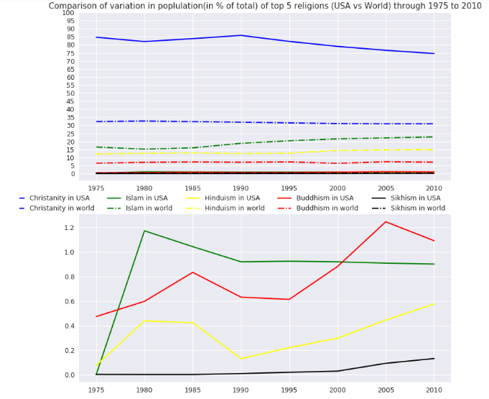

Discussion

This visualization was concerned with answering the question of How the percentage of followers of top 5 religions (Christianity, Islam, Hinduism, Buddhism, Sikhism) have grown or shrinked in US in comparison to the world over last 3 decades? The data was loaded from pew research website for the concerning areas. The data was converted into percentage terms in order to provide relative idea and not absolute numbers.

First plot indicates all the 5 religions in the world and the US. In first plot many lines are not clearly visible, hence, we drew the second plot to show the magnified view of that area. With the rise of any religion in the world the religion has grown in the States as well.